MAHARANI KASISWARI COLLEGE
EXTENSION LECTURE SERIES: LECTURE 1
Organisers: Study Circle and Seminar Committee.
Topic : Memory Studies: An Introduction
Guest Speaker: Dr. Avishek Parui
(Assistant Professor in English, Department of Humanities and Social Sciences, IIT Madras)
Date: 13th April, 2022.
The Study Circle and Seminar Committee of Maharani Kasiswari College has introduced the Extension Lecture Series for the academic year 2022. This initiative has been undertaken to enrich the academic community of the college. It is the Committee’s design to invite eminent academicians from reputed and prestigious institutes of our country to deliver lectures on upcoming, relevant and contemporary academic discourses. It is expected that both the teachers’ and student’s community of the college will reap benefits from these dynamic lectures.
The first lecture of the Extension Lecture Series, 2022 was delivered by Dr. Avishek Parui, Assistant Professor in English, Department of Humanities and Social Sciences, IIT Madras. Dr. Parui is the Founding Chairperson, Indian Network for Memory Studies (INMS). He is also the Principal Investigator, Centre for Memory Studies, Institute of Eminence ---Centre for Excellence Scheme, Ministry of Human Resource Development, Government of India. An Associate Fellow of the UK Higher Education Academy, he has contributed to over 19 Journal articles, 6 book chapters, 2 Encyclopaedia entries and 7 Projects. He is the author of Postmodern Literatures: Literary Context Series (2018) and Culture and the Literary: Matter, Metaphor and Memory (2022).
Founded by Dr. Avishek Parui and Dr. Merin Simi Raj, the Indian Network for Memory Studies is the nation’s first formal national network. Memory Studies is an academic field which began with individual memory growing outward to focus on broader dimension of social memory. It is a field that focuses on studying the use of memory as not only a tool for remembering the past but also looking forward. It is therefore a multidisciplinary field that attempts to understand the interplay of remembering and forgetting. Dr. Parui introduced the interdisciplinary nuances of the concept before highlighting the literary dimension of the concept. Since, he specializes in English Literature; he put forth the association of memory studies with literature underlining its contribution in other notable disciplines, namely Psychology.
The lecture was well received by the audience who came up with interesting and relevant questions. The Question and Answer segment was moderated by Smt. Anwistha Ganguly, Head of the Department, Psychology. The speaker answered questions on the relevance of memory studies in areas like: Oral History, Diaspora and Partition Literature, and study of Identity and its markers. Relevant texts were also briefly referred to and suggested for reading during the Q&A segment.
Professor Sajida Khatoon , Assistant Professor, Food and Nutrition Department delivered the Vote of Thanks before winding up the day’s session. The session was enriched with the active participation of faculty members and students of various Departments.

Program Schedule:

1. WELCOME NOTE--- Dr. Sima Chakrabarti (Principal). [3.00pm -3.05pm]

2. INTRODUCTION --- Dr. Chandrima Karmakar (Jt.Convenor). [3.05pm- 3.10pm]
of the SPEAKER

3. GUEST LECTURE -- Dr. Avishek Parui (Assistant Professor) [3.10pm- 4.10pm]
IIT, Madras

4. QUESTION AND ANSWER ---- Ms. Anwistha Ganguly [4.10pm-4.20pm]
SESSION (HOD, Dept. of Psychology)

5. VOTE OF THANKS ----- Ms. Sajida Khatoon [4.20pm- 4.25pm].
(Assistant Professor)
(Dept. of Food and Nutrition)

Google link for the online lecture was provided 15 minutes before the program https://meet.google.com/bpn-hyfc-oby

REPORT SUBMITTED BY:
Dr. Chandrima Karmakar
Assistant Professor (Department of English)
Jt. Convenor (Study Circle and Seminar Committee)

Related Photos/Screenshots

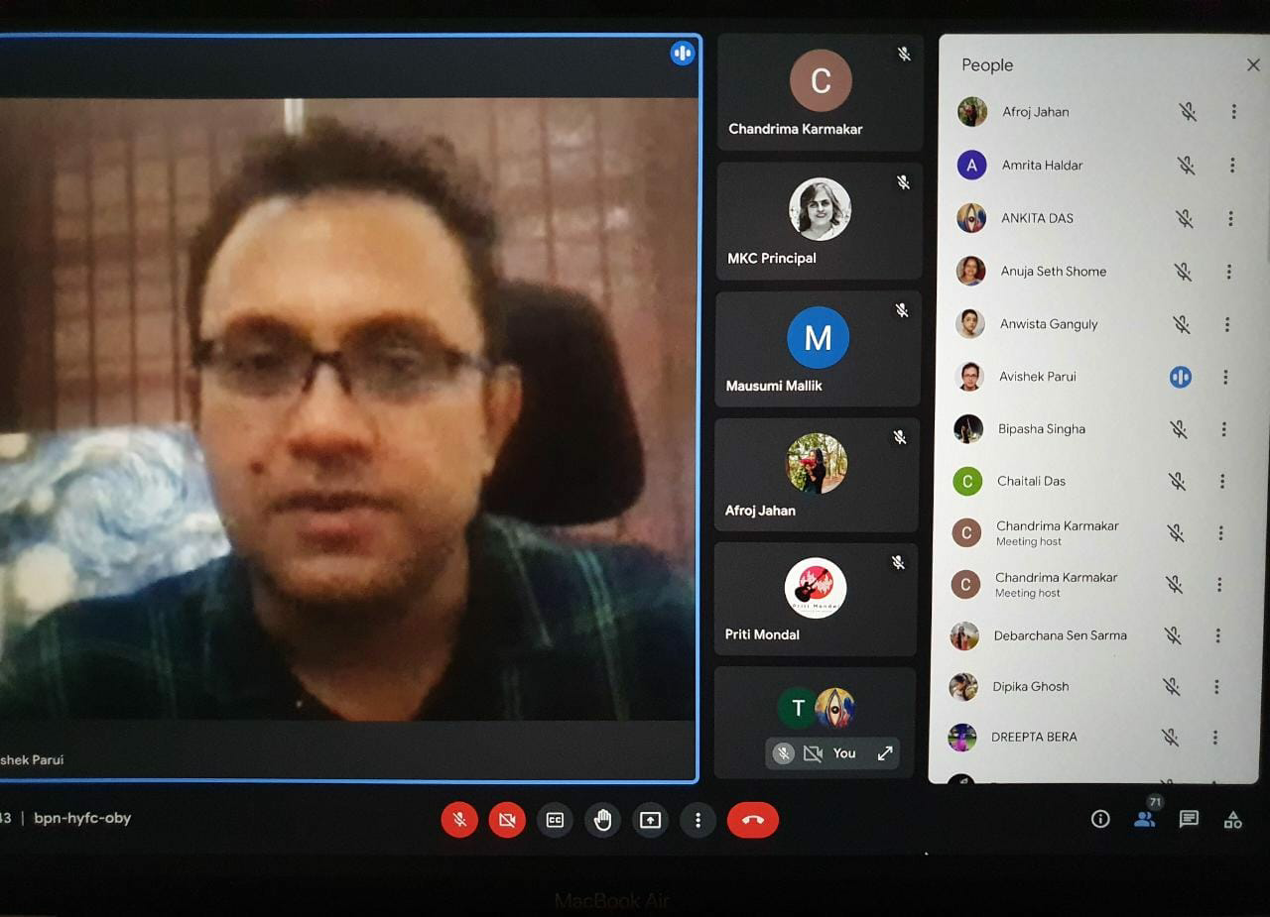
Picture -1 :- Dr. Avishek Parul delivering his lecture to the audience

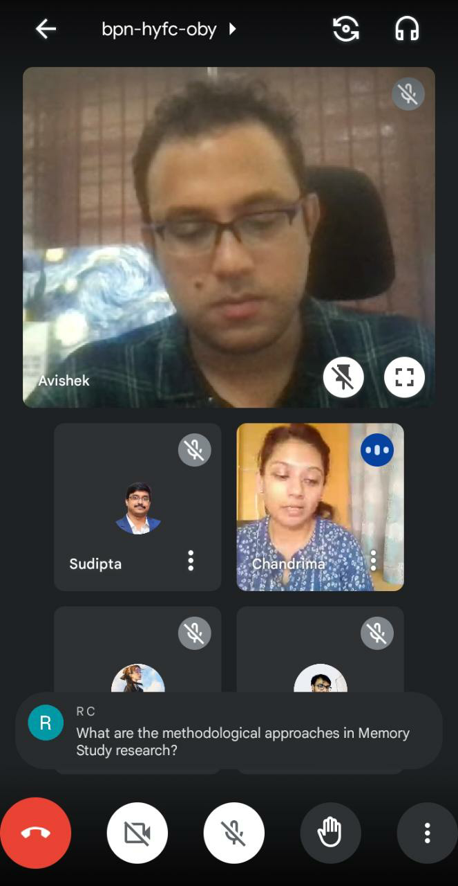

Picture-2:- Dr. Chandrima Karmakar giving Vote of Thanks

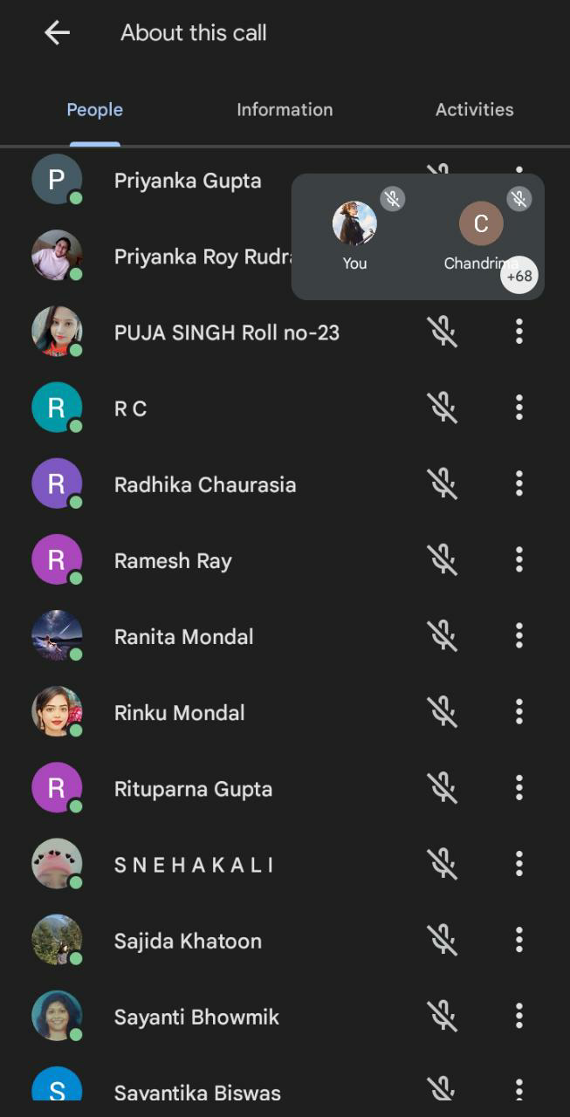
Picture-3:- Faculty and Students of the College while Attending the Webinar

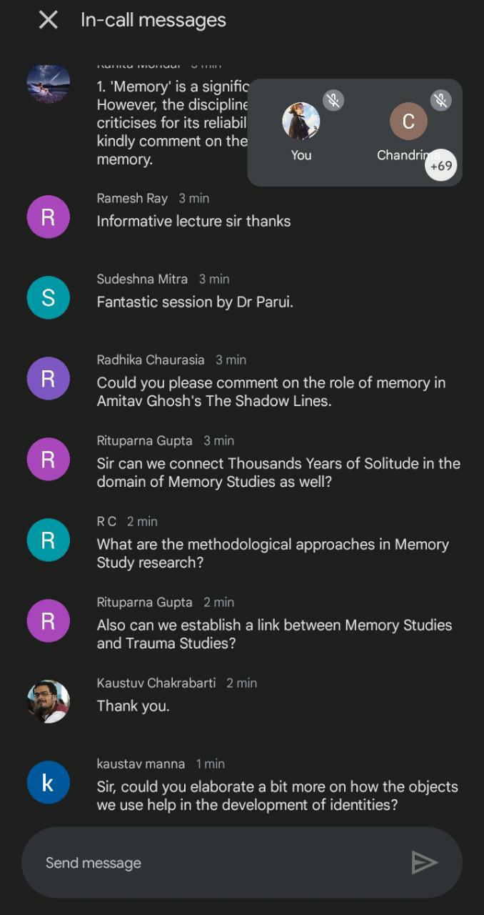
Picture-4:- Screenshot of the Questions asked by the Audience

