KULTALI Dr. B.R. AMBEDKAR COLLEGE
Vill- 11 No. Jalaberia P.O- Jamtala P.S- Kultali South 24 Parganas
Pin- 743338 West Bengal Ph- 8017954453

To
Dr. Manidipa Mitra
Associate Professor
Maharani Kasiswari College
Sub: Invitation letter to act as resource person for the “Two Day E-Special lecture series” organized by the Department of Education.
Dear Madam,
The Department of Education and IQAC, Kultali Dr. B.R. Ambedkar College, affiliated to the University of Calcutta, will be going to organize a “Two Day E- Special Lecture Series on Significance of Evaluation, Measurement and Statistics in the field of Education”, on 24/09/2021 and 25/09/2021 , Time: 3:00 p.m. to 6:00 p.m., for the benefit of the students and interested scholars and academicians. Due to the present pandemic situation, we are using the online or virtual method for the lecture series.
In the above context I would like to cordially invite you as a resource person of this lecture series on 25/09/2021 to enrich us with your valuable views with respect to the above mentioned topic through online mode.
Regards.
Thanking You
Yours truly
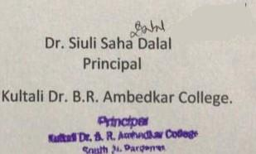
Dr. Siuli Saha Dalal
Principal
Kultali Dr. B.R. Ambedkar College
Dist: south 24 Parganas
West Bengal
India

